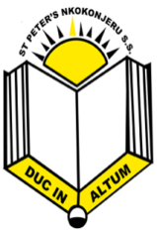
ST. PETER’S NKOKONJERU S.S
P.O.BOX 962, MUKONO.
E-mail:st.petersnkoko@gmail.com.

ADMINISTRATIVE STRUCTURE
MoES
Board of Governors
P.T.A.
Headteacher
Deputy Headteacher
Chaplain
Director of Studies (D.O.S)
Class Tr.
Welfare
Careers Tr.
Exam Tr.
Co-curr. Tr.
Ass. DOS
Librarian
D.C
S.Woman
S.Man
Compound/ Garden Tr.
Estates Tr.
T/Table Tr.
H.O.D
Contracts comm.
PDU comm.
Bursar
Nurse
Warden
Security
Cooks
Matron
Compound Staff
Sbj. Teachers
Lab. Attendants
Students Leaders
Students

